Homework No.1

Due Date: October 1 2018

A late turn-in will not be accepted

1. List 5 system services/features and provide some examples (10%)

* Process Management
  + Task Manager
* File Management
  + Windows Explorer, Drive partitioning
* UI
  + Desktop, Window Manager, Terminal
* Memory Management
  + Malloc
* Security
  + User groups, security ring levels

1. Describe 2 ways to obtain system services. (10% each)

* CLI
* GUI

1. Write a command line that lists files in a current directory and if the output is more than a page long as well as count how many files there are, it will output a page at one time until you hit spacebar. (10%)

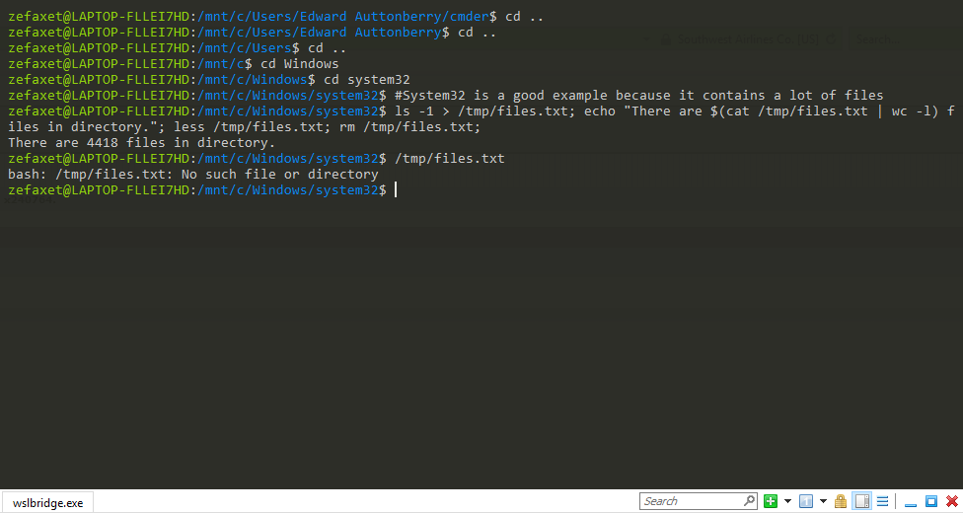

1. Describe how Unix/Linux shell locates a given executable file when you don’t specify full search path (10%)

The $PATH system variable contains various directories to search for executables in.

1. Describe how Unix/Linux shell command interpretation work (10%)

First the command is parsed. If an executable is found that matches the command and its flags, a new process is started to run the program, and the shell is suspended until the program completes execution, at which time the user is prompted to enter another command.

1. Explain redirection in Linux and what are stdin, and stdout.. what different between stdout and stderr (10%)

* There are three stdio protocols used on the command line
  + Stdin
  + Stdout
  + Stderr
    - Stderr is reserved especially for error messages whereas stdout may be used for any program output
* There are symbols for manipulating stdio
  + < redirects stdin
  + > redirects stdout to a fie
  + >> appends a file with stdout
  + | (pipe) redirects the output of a command to another command

1. Start editor (vi or emacs), write number 1-30 hit return for each and save them to a file “mynumber”. Then suspend the editor and show that it is suspended or stopped but still active (in your job list). List the file. And resume the editor. (you can either show screen capture or describe commands). Check what is a process ID of editor and parent its process ID (20%)

1. List your directory that contains mynumber file in a long format. Explain the current file permission info. Change file permission mynumber so that your group can read only (20%)

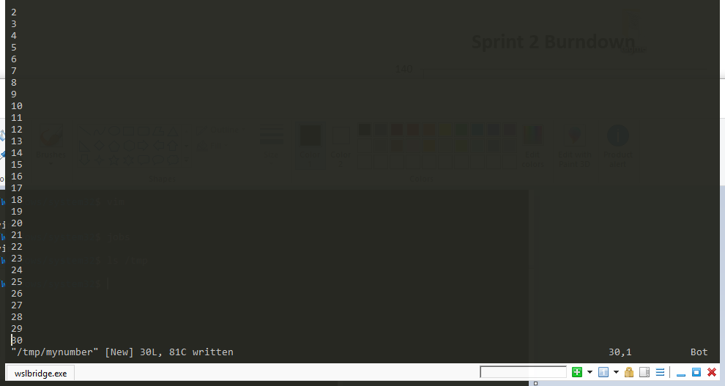

The file has been saved to the /tmp directory.

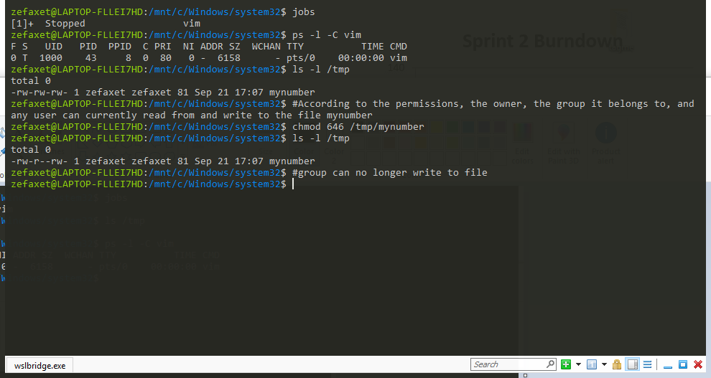

Vim process is suspended and process id and pid is listed.

File is listed with permissions before chmod. Group permissions are changed to remove write access, and permissions are relisted.